**Multi index funds Management system**

**Entity Relationship Diagram (ERD)**

1. Entities:
   * IndexFund: Contains fund details.
     + Attributes: fund_id, name, description, target_allocation, last_rebalance_date
   * Constituent: Represents the assets within an index fund.
     + Attributes: constituent_id, fund_id, asset_symbol, market_cap, allocation_percentage
   * PriceHistory: Tracks price fluctuations of each asset.
     + Attributes: price_id, constituent_id, price, timestamp
   * RebalanceLog: Records details of each rebalance.
     + Attributes: rebalance_id, fund_id, rebalance_date, changes_made, new_allocations

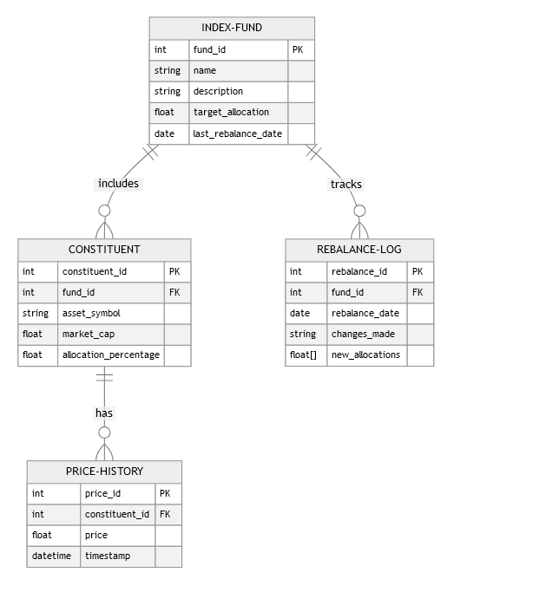

**Flow of Events When the Scheduler Runs**

1. Trigger Scheduler: The scheduler activates at predetermined intervals (e.g., hourly, daily).
2. Fetch Current Prices: Query the latest prices for all constituents from a market data source.
3. Calculate Current Allocations:
   * Retrieve the current market cap and price of each constituent.
   * Calculate the current allocation percentages based on the latest prices.
4. Compare with Target Allocations:
   * Determine if the current allocations deviate from the target allocations set for each index fund.
   * Identify the amount of rebalancing needed for each fund.
5. Decide on Rebalancing:
   * If the deviation exceeds a predefined threshold (e.g., 5%), mark the fund for rebalancing.
   * Create a list of necessary transactions to achieve the target allocation.
6. Execute Rebalance:
   * Update the RebalanceLog with the date and details of the rebalance.
   * Execute trades to adjust the holdings as per the new allocations.
7. Update Fund Parameters:
   * Adjust the last_rebalance_date for the affected funds.
   * Store updated allocation percentages.
8. Notify Stakeholders: Optionally send notifications or generate reports for fund managers or stakeholders.  
   **Activity flow diagram  
   